Gumbi-Gumbi Aboriginal and Torres Strait Islanders Corporation

ICN 1229

Notice of annual general meeting
All members of the corporation are advised that an annual general meeting of the members of Gumbi-Gumbi Aboriginal and Torres Strait Islanders Corporation will take place as follows:
Time: 10.00am
Date: Friday, 24 November 2023
Place: Dreamtime Cultural Centre, 703-751 Yaamba Road, Parkhurst
Technology: Microsoft Teams and Phonelink

On arrival at the meeting, members should check the register of members and if needed, update their name, address and any other details.

Agenda
Item | Description
1 | Welcome, attendees and apologies:  1.1 Confirm the chair for the meeting  1.2 Attendees  1.3 Apologies  1.4 Quorum
3 | Minutes of the previous meeting of members:  - Confirm the minutes – Friday, 25 November 2022  - Matters arising
4 | Corporation reports:  - CEO report  - Directors’ report  - Financial report  - Auditor’s report
5 | Questions about how the corporation is managed
6 | Appointment of an auditor for the next financial year and set the audit fee, or authorise the directors to set the fee
7 | Election of directors
8 | Special resolution  The following special resolution will be proposed at the meeting:  - Proposed special resolution: That Lifetime Membership to accorded to Aunty Hazel Kaur, Aunty Patricia Leisha, Uncle Samuel Kawane and Aunty Geraldine Carter
9 | Any other business
10 | Close

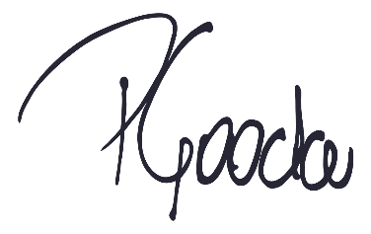
Regards,

Paul Gooda
Secretary/Contact Person

